Algerian Forest Fires — Inference Specialist Summary
Multiple Linear Regression, Interactions & Polynomial Modelling of Weather and Fire-Risk Indices

Problem Statement
Using 243 observations of weather and fire-weather indices from two Algerian forest regions (Bejaia & Sidi Bel-abbes), an Inference Specialist must quantify how temperature, humidity, region and fire occurrence relate to relative humidity and to the Fine Fuel Moisture Code (FFMC), and how ISI + BUI recover the Fire Weather Index (FWI). The emphasis is on interpretable coefficients, interaction effects, curvature and assumption checks—not black-box prediction.

Solution Strategy
1) Multicollinearity screen (heatmap / VIF) → 2) EDA scatters coloured by region or fire → 3) MLR with categorical main effects (humid ~ temp + region) → 4) Interaction model (FFMC ~ temp × fire) → 5) Quadratic polynomial (FFMC ~ humid + humid²) → 6) Multi-predictor & derived-index models → 7) Residual diagnostics & simulation sensitivity. The same pipeline transfers to any domain by swapping the CSV.

Solution

Key Model Results
Humidity model: humid = 142.58 − 2.39·temp − 7.25·I(Sidi Bel-abbes). Each +1 °C lowers humidity by ~2.4 pp (parallel across regions); Sidi Bel-abbes is systematically ~7 pp drier.
FFMC interaction: No-Fire slope ≈ +2.45 FFMC/°C; Fire slope ≈ +0.56 FFMC/°C. The interaction term (−1.89) shows that once a fire has occurred the temperature–FFMC relationship flattens dramatically.
Quadratic FFMC: FFMC = 77.63 + 0.75·humid − 0.0114·humid². Curvature is mild at low humidity but steeply negative after ~35 %, confirming that linear models understate the protective effect of high humidity. FWI ~ ISI + BUI recovers R² ≈ 0.97 (expected by construction).
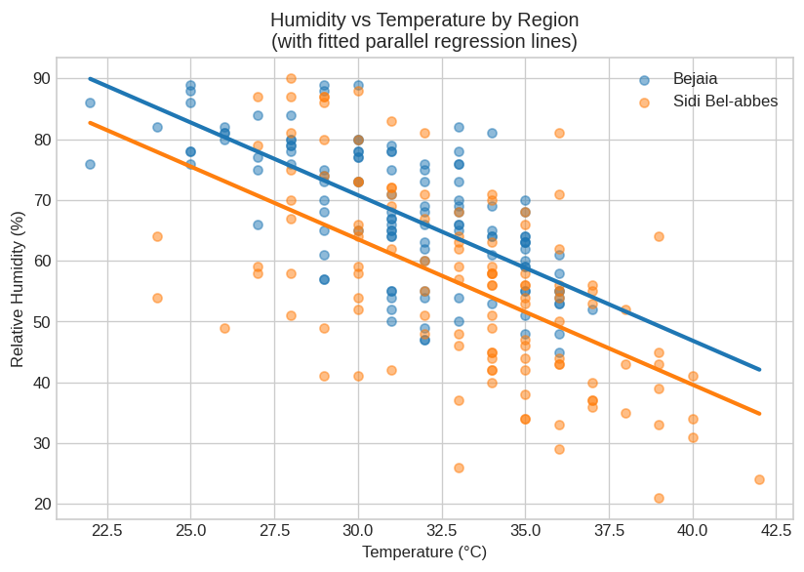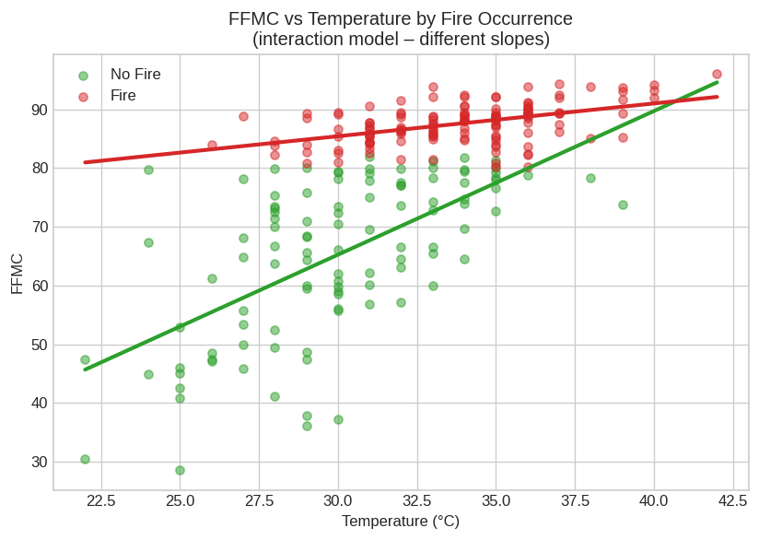
Left: Humidity vs Temp by region (parallel fits). Right: FFMC vs Temp by fire (interaction – different slopes).
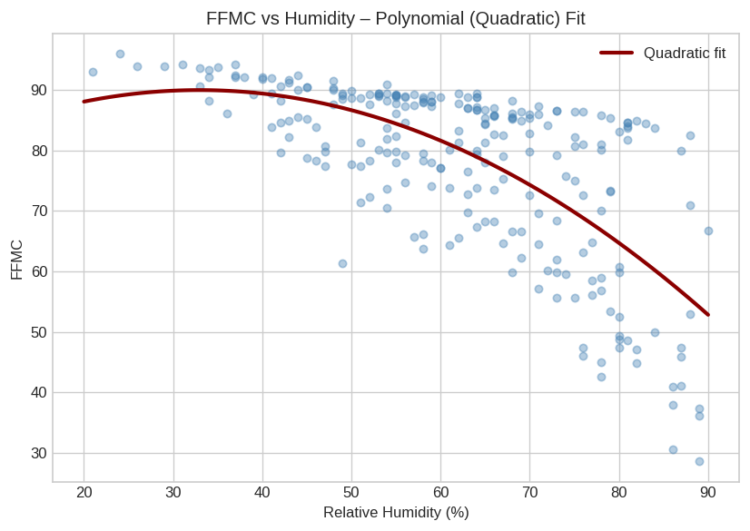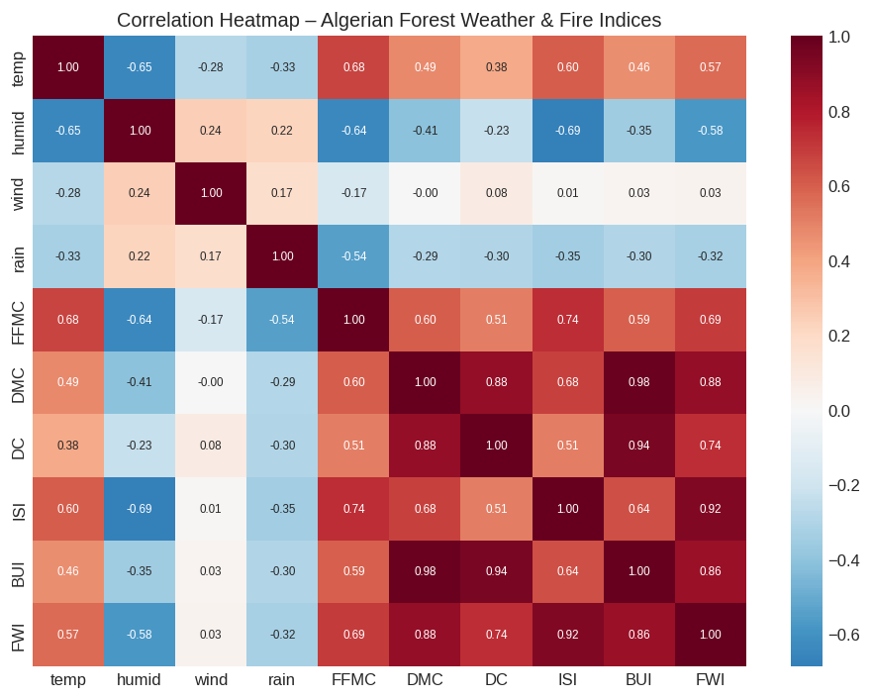
Left: Quadratic FFMC–humidity curve. Right: Correlation heatmap (DMC/BUI/DC/FWI highly collinear).

Key Takeaways
• Temperature strongly reduces humidity (≈ −2.4 pp/°C) equally in both regions; Sidi Bel-abbes starts ~7 pp drier.
• An interaction is required for FFMC: the temperature gradient is steep only when no fire has yet occurred.
• FFMC–humidity is quadratic; linear approximations miss the increasing protective effect of higher humidity.
• Derived indices (DMC, DC, BUI, FWI) are collinear (VIF ≫ 10); never enter more than one as simultaneous predictors without theoretical justification.
• The identical Inference-Specialist pipeline (EDA → multicollinearity → MLR / interaction / polynomial → diagnostics → simulation) transfers to healthcare, marketing, agriculture or finance by changing only the data file.

